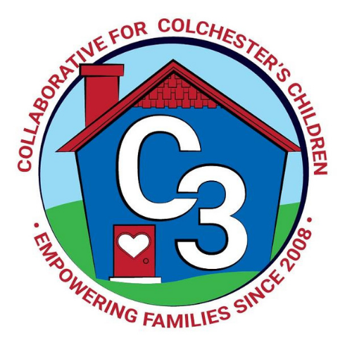
Colchester School Readiness Council
January 25, 2024
CES Conference Room/Google Meet
Time: 5:30 – 7:00 p.m.
Meeting Minutes

Attendance: Cindy Praisner, Laurie Buyniski, Kristina Swain, Jennifer Lombardo, Meghan Amado, Jennifer Rummel, Lindsay Therian, Teresa Messervy, Kaitlin Cassidy, Eve Hurley, Judy O’Meara

McKinney-Vento Homeless Update: The council was introduced to Eve Hurley, who was recently hired into the role of Director of Pupil Services and Special Education. A new, updated brochure has been distributed to council members which reviews the McKinney-Vento laws and eligibility requirements.

OEC/SR Updates: C. Praisner reported that there has been no news about the status of the RFP. If it is not an open year, then new programs may not be eligible to apply.

SR Budget Update: Castle has received both payments for COLA. Salary has not yet been adjusted for C. Praisner as mentioned last month. Council approved Castle’s request for playground equipment. Council also approved sub-pay for CECP teachers attending Circle of Security Classroom training. The first payment was made to J. Lenares for Fall monitoring.

Current SR Classroom Status: C. Praisner reported that the programs are at full enrollment.

SR Program Monitoring: Currently in the process of setting up winter monitoring visits. The TPOT (Pyramid) will be used and has been distributed to teachers in advance so that they can understand the areas that will be evaluated.

Castle Cost of Care/Audit: The cost of care at Castle is $788/month for school day. CECP cost of care is $250/month Part-day and $650/month school day.

Sparkler Update: Funding for the Sparkler grant has been extended to the end of February, so there is some additional time to spend for programs and activities that have been planned. December events included Sing & Sign and Joyful Noises at the Library. Two events in January at Cragin offered families time to complete the ASQ and receive support from staff when doing so. Families who completed the form received a $25 gift card to Stop & Shop.

C3 may receive $15k through the LECC which may further extend the work on the Sparkler initiative; however, the time frame for receiving the funding is unknown, and may potentially need to be spent by June.

Peace at Home Parenting Portal: C3 and Y&SS have partnered to offer the Colchester community access to the Peace at Home Parenting Portal which is a website of tools and resources for parents of children of all ages. It includes live, interactive workshops, quick video solution library, recorded videos, handouts, and blogs. It will be piloted for 6 months in order to determine usage. Colchester is sharing the cost with Lebanon.

Kindergarten Waiver Process and Assessment: At this time, council members moved to the CES media center to participate in the Kindergarten Waiver and Process meeting that was held for parents. CES Administration reviewed the process and answered questions from families considering seeking a waiver.

2023-2024 Meeting Dates

March 14
April 18

Submitted by:

Laurie Buyniski, Assistant to the Coordinator

