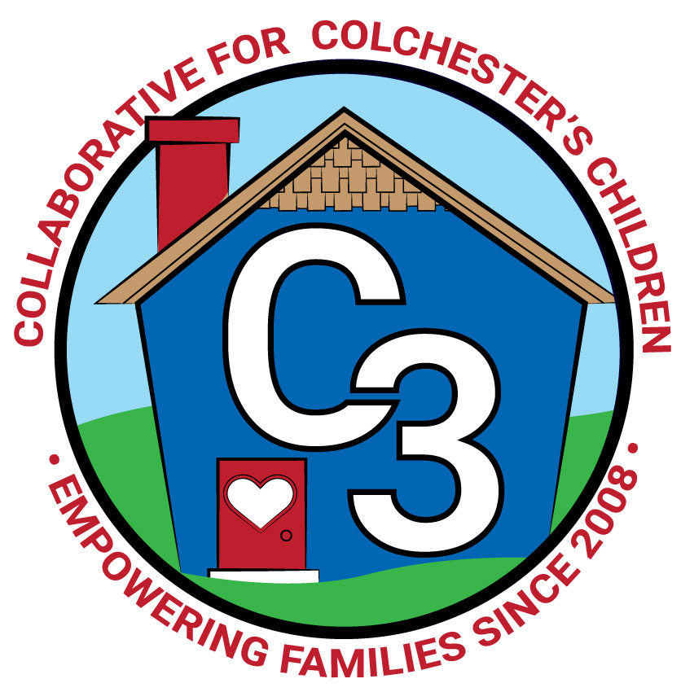
COLLABORATIVE FOR COLCHESTER’S CHILDREN
March 7, 2023
Leadership Work Group Meeting
Cragin/Google Meet Hybrid
9:00-10:30 am

Attendance: Jennifer Rummel, Nina Bryant, Teresa Messervy, Kerry Zrenda, Cindy Praisner, Laurie Buyniski, Julia Lash, Brittany Hebert, Nicole Sargent, Kate Byroade, Judy O’Meara, Ashley Starrett, Beth Tiezzi, Meghan Amado, Rosemary Gignac

Partner Updates
Cragin - Summer Reading Program has been planned, will be printed in Colchester Connection publication. Two copies of Dr. Becky's new book ‘Good Inside’ are now available. Most Museum passes are now online to check out.

TVCCA/WIC - Early Head Start and Head Start not fully enrolled (6 HS, 8 EHS), continue to look at ways to improve enrollment numbers, such as attending the community event at Lebanon Children’s Clothing Wardrobe, moving to online application process, SNAP is automatic eligibility. Accepting applications for next program term. Some job opportunities are available, although facing the same challenges as others in the child development workforce.

JJIS -Family Learning Night (4/20) has been planned, Earth Day theme. Local author Sandra Horning, (‘The Biggest Pumpkin’) will be coming. K. Zrenda shared a flyer for the event and asked for it to be distributed wherever possible.

CASTLE - Preschool Open House will be held to offer families a tour of the school and provide information about the program. Hosting a Trivia Night fundraiser on March 25th. Planning for Summer and Fall, currently assessing space availability.

CES - Board of Finance meetings scheduled for March 7th and 14th. Pre-K lottery has not been pulled yet, hopefully will be completed by the end of March. Pre-K tuition for Part-Day $75/month, School-Day $150/month, 13 applications received for School Readiness spaces; number is low due to not having reached out to lottery families. The Superintendent has proposed the 23-24 School Budget, BOF will review both town and school budgets, designated time for citizens comments at budget meetings, attendance is encouraged.

Parent Council Updates - B. Hebert reported that February Parent Council meetings were cancelled, March meetings to be scheduled soon. Beginning to plan for Farmers markets, fundraisers (Kidsignments 3/25 and Mel’s 4/24 @5-9pm). Discussed how to engage home-school families.
OEC Ambassadors - J. Lash planning to meet with HS & EHS families for coffee & feedback in the conference room at CES.

C3 General Updates - C. Praisner reported that the budget is on track for spending. LECC will likely have another grant available, waiting to hear more details on the process. Will likely use funds to pay ahead for programming. Discussed ways for families to donate; suggestion of small gift of swag for donation such as sticker or grocery bag, explained the non-resident donation process. Parent stipends have been purchased in the form of Amazon gift cards, not distributed. Paying out for Winter Joyful Noises, some class offerings changed due to low enrollment, survey showed families were absent primarily due to illness. SR funding remains steady. C. Praisner reviewed charts to show where C3 funding has come from over the past several years. Funds in the governor's budget for OEC are in jeopardy; have invited local legislator Mark DiCaprio to Joyful Noises on March 23rd to discuss our work and show him how funding helps our programs. Considering an evening PEP class; will send a survey to families to gauge interest.

Community Plan & SWOT Analysis: Members reviewed current Community Plan including strengths and opportunities. Members brainstormed ideas/comments from SWOT Analysis to add/revise the community plan:
- Recent weekend events (Storywalk pop-up event and Joyful Noises on Saturdays) have been successful in reaching working families.
- Make the most of cross-community partnerships
- Welcome packets for new families
- Signage at Park & Rec facilities, Storywalk
- K-3 programming (older version of Joyful Noises, Lego, Art)
- Workshops for families with older children
- Promote which classes can be retaken
- JN in daycares, timing when parents can be there, communicate with daycares regarding expected family engagement
- Cragin will be having older child ‘activity station’ program on Saturdays in July/August, families stay with kids
- Summer Reading nights at the Library - C3 info table (June 26th-Aug 7, 6-7PM)
- Build out calendar of opportunities for C3 to be at already existing events
- WIC Breastfeeding Support at the library (postponed from April 2020)

Meeting Dates for 2022-2023
May 2, 2023

Submitted by:
Laurie Buyniski, Assistant to the Coordinator

