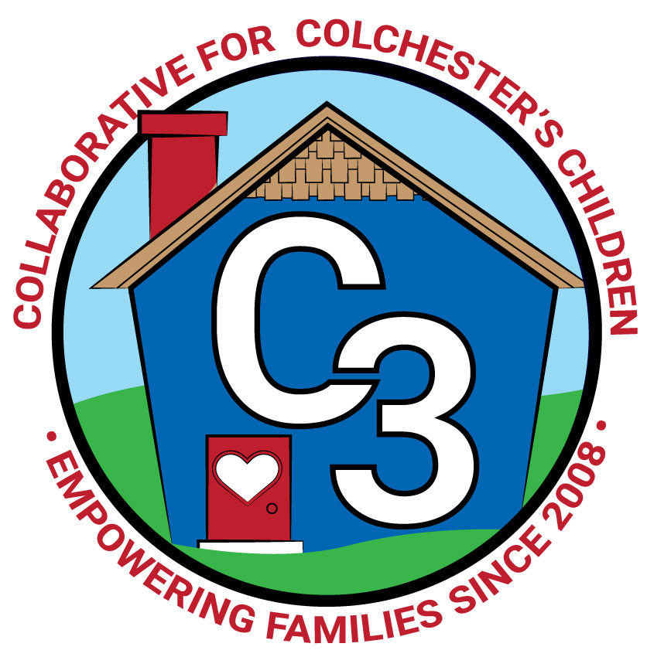
COLLABORATIVE FOR COLCHESTER’S CHILDREN
October 17, 2023
Leadership Work Group Meeting
Cragin/Google Meet Hybrid
9:00-10:30 am

Attendance: Cindy Praisner, Laurie Buyniski, Judy O’Meara, Nicole Beauchamp, Jamie Shannon, Brittany Hebert, Kerry Zrenda, Teresa Messervy, Nina Bryant, Julia Lash, Kate Byroade, Meghan Amado, Val Erie.

Partner Updates
Cragin - K. Byroade reported that the circulation numbers are close to pre-pandemic levels. Fall storytime sessions are in progress and the Fall Play with Me program has begun.

TVCCA/WIC -
Welcome to Jamie Shannon, new to the role Assistant WIC Director/Program Nutritionist.
T. Messervy offered an update on HS/EHS. New state legislation impacting K eligibility (Effective in the fall of 2024, children will need to turn 5 on or before September 1 of the school year in order to be automatically eligible to enroll in school.) will impact numbers and may need to make some shifts for increased number of 5 years olds in program. Sept/Oct likely under-enrolled due to workforce shortage, continued minimum wage increase (which impacts eligibility) Considering strategies to address Full Enrollment Initiative, such as relocating Colchester slots to Waterford, wage adjustment for staff, online applications, video tours, etc.

JJIS - K. Zrenda shared that SEL - Second Step curriculum is beginning during morning meeting (8:45-9:00) each day. Working to promote leadership among 5th graders by allowing students to read morning announcements. 3rd grade is starting to use Wonders curriculum. 4th & 5th grade have begun using a new grammar program called Patterns of Power, which is an inquiry based program, helps students to uncover grammar patterns.

Youth & Social Services - V. Gaeto reported that there is an opening for a Substance Abuse Counselor, support for WJJMS and Bacon. Hoping to fill the position quickly as there is no interim. Remodel and repairs for the Youth Center building are ongoing as water is still getting inside. All programs are currently full. Supporting Kids with Anxiety program will take place on Wednesday, Oct 18th @ 6:30-7:30pm, will determine if families are interested in continuing the conversation with on-going talks/programs
Grant funding has been received from the Herden Fund to support families with a specific need and help them move toward self-sufficiency. Collaborating with C. Praisner to identify a few families and develop a process for supporting them.

CASTLE - N. Beauchamp reports that Castle has received accreditation from NAEYC through Jan 2029. There has been an increase in demand for morning care. Currently there are 3 Full Day prek spots open (4 year olds).

CES - J. O’Meara reports that the school year is off to a good start. There are currently lottery openings in PreK (both am & pm), students must be 3 years old. Lottery applications for next year are now being accepted, the link for screenings has been updated on the district website. One School Readiness part-day space is open.

Parent Council Updates
Parent Council Co-Leaders:
Parent Council meeting was held on Oct 19th, alternating between day and evening times, to hopefully accommodate members’ schedules. Working on refreshing the membership roster and clarifying roles within the Parent Council. Events and Fundraising positions are still open.

Parent Ambassadors:
J. Lash reported that OEC Parent Ambassadors met last week, learned what Groton Parent Ambassadors are doing to reach local neighborhoods. An in-person meeting will take place in December. Attended Facilitation First training on October 24th.

C3 General Updates
-C. Praisner updated members on the Annual Meeting, which took place on September 18 in the Bacon Academy Bobcat Preschool classroom. There were 20-25 people in attendance.
-Programs currently running include 5 sessions of Joyful Noises, 1 Baby & Me, 1 Village and Conscious Discipline (daytime). Circle of Security begins Oct 17th, may possibly pilot with CES staff. Community Baby Shower took place on Oct 11, 10 registered, will be connecting with families that could not attend in person.
-C3 received a grant in the amount of $10k to promote the use of the Sparkler App in the Colchester community. The app offers an objective assessment of child development and play activities for parents and caregivers to support their child. K. Cassidy leading the initiative for C3; working with families and outreach opportunities and events.
-Prek - K Collaboration meeting will take place on Oct 25th, CES Administration and K teachers to share information about the new Reading, Social-Emotional Curricula for local providers.

Event Schedule
Oct 19 - Parent Council Meeting, 6-7:30pm, childcare available
Oct 28 - Trick or Trunk, Parent Council will host a trunk, 4:30-6:30pm
November - planning pop-up event at the Storywalk for Sparkler on a day off from school
Dec 9 - Sparkler Music & signing event to be held at Jazzercise Studio, 10:30-11:30am
Dec 16 - Saturday Joyful Noises at Cragin, additional dates scheduled for the Spring

Budget Update
No update to report at this time.

Strengthening LECC Grant
C3 received $24k in OEC grant funds through the state to continue early childhood initiatives, may possibly continue for next 2 years; however this is uncertain. Funding to support the role of Family Empowerment Facilitator (J. Lenares) in the amount of $9k coming form ARPA at this time and may need to rely on grant in the future. Additional activities supported by grant funding include Parent Council activities, Town-wide mailing, Family Place training for library staff, Community Baby Shower, Conscious Discipline Course (8 hour online self-paced), Marketing materials including shirts for staff, permanent signs at Storywalk and Rec Plex, and program administrative expenses such as registration software, childcare, facilitators.

SWOT Analysis Review
Council members reviewed the SWOT analysis completed earlier in the year and discussed potential opportunities to continue to support the work of C3. Discussed the lack of permanent programming space, needs of the most vulnerable population such as transportation and housing, efforts to build a new cadre of parents, adding C3 info to new family folders distributed by the district.

Meeting Dates for 2023-2024
Tuesdays, 9:00 - 10:30 am
November 28
January 9
March 5
May 7

Submitted by:
Laurie Buyniski, Assistant to the Coordinator

