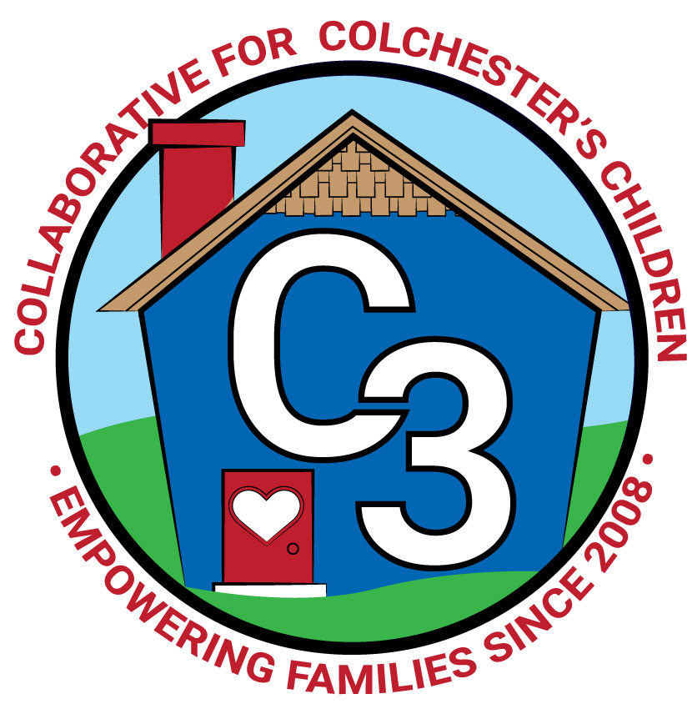
COLLABORATIVE FOR COLCHESTER’S CHILDREN
March 5, 2024
Leadership Work Group Meeting
Cragin/Google Meet Hybrid
9:00-10:30 am

Attendance: Cindy Praisner, Laurie Buyniski, Brittany Hebert, Kerry Zrenda, Julia Lash, Jennifer Rummel, Meghan Amado, Jamie Shannon, Teresa Messervy, Kate Byroade, Jennifer Rummel, Judy O’Meara, Nicole Beauchamp, Dan Sullivan

Partner Updates
Cragin - Five week session of Storytime and Play with Me (12 months - 3 years) has finished. Eight week Spring session will begin at the end of March. Starting to plan for the Summer reading program - theme is Adventure at the Library. K. Byroade shared that there is advocacy at the state level of legislation regarding school libraries and the importance of research skills beginning in Kindergarten for which certified school librarians are crucial.

Castle - Currently accepting registrations for preschool and summer programming. Munson’s fundraiser and Trivia Night Fundraiser are coming up.

TVCCA/WIC -
Head Start and Early Head Start are on ‘under enrollment plans’, have 12 months to look at causes and potentially propose changes. T. Messervy shared Up & Away resource flyers for C3 to post on social media. Participating in a family fun night in Montville and trainings for teachers.

WIC - Nationwide uncertainty regarding continued funding, cuts would impact the ability to provide services to families. Currently hiring for a part-time nutritionist in the Norwich/New London area.

JJIS - Continuing to plan the Learning night event, now called Family Fun Night, March 14th - theme will be Journey/Adventure, coincides with book fair and Tape a Teacher fundraiser.

CES - PreK Lottery was pulled and families were informed. The deadline to apply for the Kindergarten waiver process was March 1st. Assessments will be scheduled with families that requested the waiver. First assessment will take place on March 8th. Families will likely be notified by the end of April regarding whether or not the waiver has been approved so they have enough notice to plan. Kindergarten story hour will take place on March 14th at 11 am with focus on Math curriculum. Central office will conduct a registration day to help families complete needed paperwork. Ten CES teachers completed Circle of Security classroom training with J. Lenares. It was well received and would like to hold another session. J. O'Meara is currently participating in FLIP IT training with local preschool providers.

Parent Council Updates
Parent Council Co-Leaders:
C3 received $492.44 from Inishmor Dine out Fundraiser which was held on February 8th. Future fundraisers are planned for Mel’s Downtown Creamery, Sweet Aroma and FlipGive.
Council leaders are planning to create a feedback survey to understand why families are not connected to C3. The next Parent Council meeting will take place on Thursday, March 21st, 6-7:30pm at Cragin.

C3 General Updates & Events
-Spring sessions of Play & Learn groups begin the week of March 11th. Classes are filling up. -Planning a self-care aromatherapy event (How to Make Shower Steamers) on March 13th at Cragin, 6-7PM
-Storywalk Pop Up event on March 8th with cocoa on school day off, 10-12PM.
-People Empowering People Class began on February 29, evening session on Thursdays through May 16th, 7 participants.
-FLIP IT will run for a 5 week session, began on Monday March 4th, 12 participants.
-Joyful Noises Saturday at Cragin will be held on April 27th, 10:30-11:30am
-Self-care/Nutrition event, How to Make a Charcuterie Board took place on February 7th and was well attended.
-Love Languages workshop was held virtually on February 12 at 8PM.
-Reminder that Conscious Discipline Online Training is still open, C. Praisner will send an email out to those registered with a progress update.
-Promotion efforts for Peace at Home Parenting portal include banners to be hung in the school, palm cards to hand out at events and for teachers/staff to hand to families at conferences and PPTS, table tents for restaurants.
-Continuing to promote Sparkler with social media consultant Megan Gauthier. K. Cassidy is no longer working on Sparkler efforts as she will be covering Joyful Noises classes for S. Wilinski while she is out due to surgery. Looking for someone to help about 4 hours/week with Sparkler initiative.
-Planning to host a Community Baby Shower in the Spring

Budget Update
Coordinator salary needs to be adjusted because funds are not being taken out of the correct account, a request was made to the finance department to resolve this issue.
C. Praisner reviewed the updates to budget allocations including parent council activities, staff professional development, marketing for Peace at Home Parenting portal, Community Baby Shower, Rivereast insert and supplies.
C. Praisner also reviewed the School Readiness budget updates; J. Lenares will complete winter monitoring visits, FLIP IT for providers, and funds were also paid out for CECP subs (for training), and Castle’s waffle block playground equipment.

Strengthening LECC Grant
No further update on the additional anticipated funding from LECC - $15k Jan-June, $15k July-Dec. Planning to use funds to cover the costs of Parent Council stipends, Freelance Social Media consultant, Sparkler Coordinator, Rivereast insert. Planning to pay out for Play & Learn groups when LECC funding comes through.

Asst to Coordinator Position Change
C. Praisner explained to council members that upon reviewing town positions and job descriptions, the current Assistant to the Coordinator job requirements were more similar to a Program Coordinator role rather than an assistant position. A change to the job title, small changes to the description, and pay was proposed. This was reviewed and discussed with the executive board members on February 22nd and approved to bring to the full Leadership Work Group. Collaborative members agreed to change the job title to Program Coordinator along with a pay increase to $28/hour to be more aligned with other town positions and better reflect the work already being done by the individual in this position.

Budget FY 25
C. Praisner reviewed the FY 25 draft budget with council members. (see attached) Funding for J. Lenares will likely come from the LECC grant because ARPA funding has expired. C. Praisner proposed a 2.25% increase for program facilitators, to be in line with what the town provides employees as an annual increase. SR Budget 24-25 was also reviewed; updates from the state should be provided soon along with guidance on the grant process for the upcoming year.

Check-In
C. Praisner asked members to share thoughts on how meetings are working; what's going well, what could be changed or improved.
What’s going well | What we can change
-time of meetings  -agenda and documents are sent in advance  -partner updates  -seeing everyone from the community and hearing different perspectives  -amount of time for updates  -parent leadership at the table  -those who attend are contributing | -zoom/hybrid capabilities are sometimes challenging  (discussed the possible use of other spaces such as BOE conference room, library owl)  -no longer have some community representatives that used to attend (YSS, P&R, Faith, BOF/BOS, UCFS)

Council members agreed to complete a self-assessment, verbally, at the next meeting on major topic areas.

Upcoming Meeting Dates for 2023-2024
Tuesdays, 9:00 - 10:30 am
May 7

Submitted by:
Laurie Buyniski, Assistant to the Coordinator

