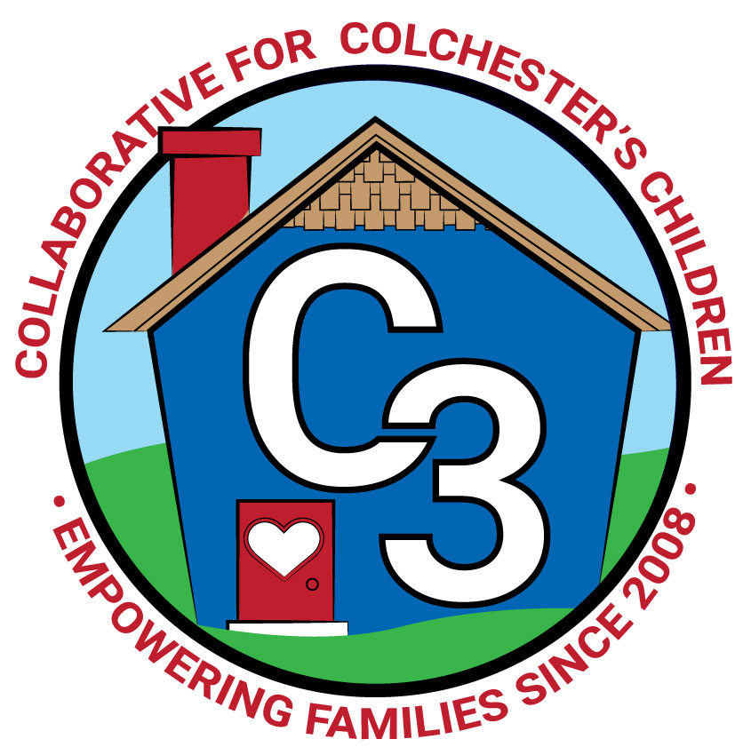

**COLLABORATIVE FOR COLCHESTER’S CHILDREN**

**April 1, 2025**

**Leadership Work Group/School Readiness Meeting**

**Cragin Memorial Library**

**9:00-10:30 AM**

**Attendance:** Cindy Praisner, Laurie Buyniski, Regina Brady, Julia Lash, Jennifer Rummel, Kaitlin Cassidy, Rosemary Kelley, Kate Byroade, Meghan Amado, Jamie Girvin, Nicole Beauchamp, Jennifer Lombardo, Dan Sullivan, Eve Hurley, Jessica Kuckel, Sarah Russel, Teresa Messervy

**OEC/SR Updates -**

**LGP Transition Process**

C. Praisner shared some highlights of the expected LGP requirements including ½ time liaison, ½ time coordinator, and paid Parent Ambassadors. In addition, increased coaching for programs, potential changes to the application process which is currently centralized, and merging of SR and C3 bylaws. The LGP funding will be provided for two year period. The space allocations will become competitive based upon a community needs survey in July 2027. Administration money and dollars contracted directly with programs could change again.

C3 will apply for a grant to support the council in the LGP transition process. The funds will cover 20 hours for a consultant and laptop for C. Praisner plus miscellaneous meeting expenses. Deb Adams, consultant in contract with EastConn, will be hired to support the process of preparing for the LGP application, as well as identifying any gaps. Consultant will make recommendations so that C3 is best prepared to submit a strong application and prove the work can be accomplished.

**Early Start CT Updates**

Applications for students will be reviewed mid-May. An interest survey to current CECP families will be sent out regarding school day options. Our application process will remain the same for this year.

Future C3 meetings are scheduled for May 13 & June 10 to ensure application for LGP can be completed and approved.

**Partner Updates**

**Castle** - Preparing for summer and fall registration. Seeking a new Head PreK Teacher. SR monitoring visits will be scheduled for the Spring.

**CPS** - D. Sullivan shared budget season updates with the council. The second budget workshop meeting will be held tonight with the Board of Finance, discussion will cover impact to programs considering a 0% increase as well as $1M decrease scenarios. Budget Public Hearings will determine the adopted budget to be sent to the Town Meeting. Town Meeting is scheduled for May 22. Referendum is planned for Tuesday, June 3. [Board of Education budget materials can be found here.](https://www.colchesterct.org/board_of_education/education_budget)

**CECP** - Kindergarten registration is open. The next Kindergarten storytime will be held on April 22. Kindergarten Orientation will take place on May 15th, two waves 4:30/5:30 for students and parents to attend. There are two PreK Special Ed teacher openings at CES.

**Cragin**- Preparation for the Summer Reading program continues, planning for Fall.

**TVCCA**-

Family Bridge, Universal home visiting program continues, Colchester will be part of phase 2, currently receiving referrals from Colchester, will serve beginning in November. Working collaboratively with the OEC, looking for more avenues to help families.

HeadStart - waiting for grant to be approved, staffing improving and therefore hours will be returning to regular schedule as a result. Enrollment at 90%, preparing for new three years olds entering the program.

WIC - increasing caseload, fully staffed, farmer’s market season will begin in June

**Parent Updates:**

**OEC Ambassadors** - Regional Parent Ambassadors and Parent Cabinet members met last week. Currently planning for a Parent Cafe event in May, will be meeting tonight, considering using the Brain Architecture game.

**Parent Council** - Council is wrapping up events for the school year, fundraisers include Sweet Aromas, MandiLee Photography, Inishmor & Mel’s with Rock Painting. Also, planning an end of year field trip or activity for Parent Council members.

**McKinney-Vento Homeless Update** - Nothing new to report.

**Local SR Updates -** Winter monitoring is complete, Castle 10 SD/SY, CECP 14 SD/SY, 21 PD/SY. Program contracts for school year 25-26 are being developed. Financial assistance request for June was considered and approved. Council members discussed potentially changing the financial assistance request process for ‘25-26 in order to require documentation for reduction or waiver, possibly using a small team to evaluate the request, in order to gather more information while also keeping the privacy of the family.

**C3 General Updates and Events -**

Community Baby Shower planned for Monday, April 7th, 6-7:30 PM at Cragin, 4 families have registered.

Spring Play & Learn Groups begin; Joyful Noises (5 sessions), Baby & Me, Stroller Walks continue

Parent Education; Conscious Discipline for Dads, Stroller Walks, Healthy Tech Habits, Wise Mind Workshop, Family Dance Party, FLIP IT (daytime), CD Refresher, COS Refresher for CES, Colchester Unplugged initiative.

**Budget Review -** No changes to the budget to report.

**Upcoming Meeting Dates for 2024-2025**

May 13 at Cragin Memorial Library

June 10 at Pupil Services Office

Submitted by:

Laurie Buyniski, Program Coordinator