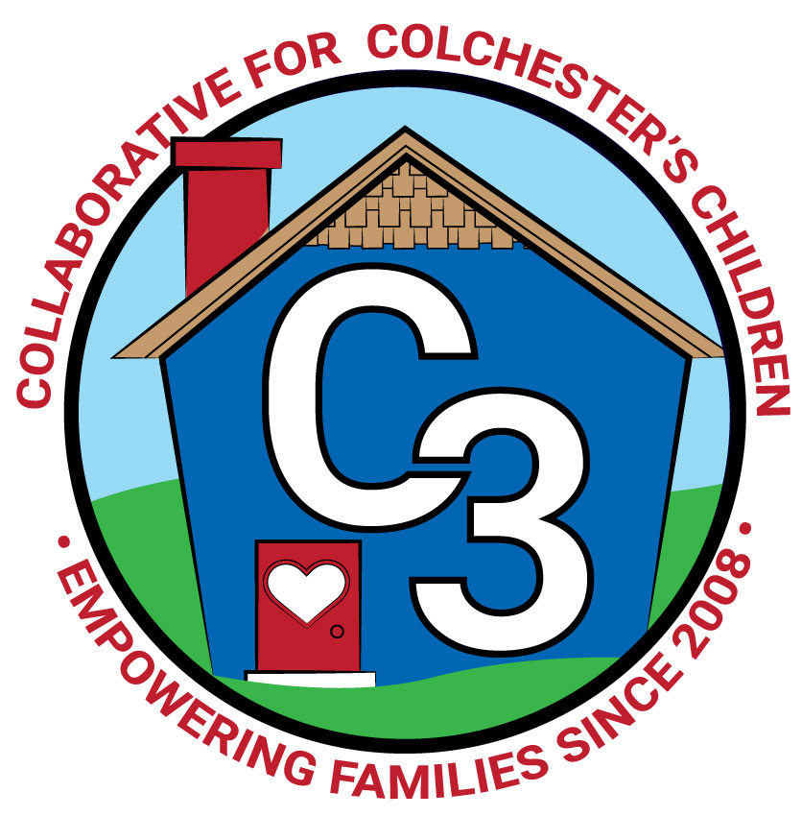
COLLABORATIVE FOR COLCHESTER’S CHILDREN
November 29, 2022
Leadership Work Group Meeting
Cragin/Google Meet Hybrid
9:00-10:30 am

Attendance: Jennifer Rummel, Abigail Dunbar-Willbanks, Nina Bryant, Teresa Messervy, Kerry Zrenda, Ashley Starrett, Cindy Praisner, Laurie Buyniski, Julia Lash, Brittany Hebert, Judy O’Meara, Meghan Amado, Val Geato, Nicole Sargent

Partner Updates
Y&SS - Position posted for Social Services coordinator. Working with CES & JJIS to create attendance partnerships; planning to hire a part-time truancy outreach worker, role will include connecting with families to help improve school attendance.

Cragin - Kindergarten classes recently visited for a field trip, which included puppet show and library card registration. In person storytimes started. The December calendar includes vacation week activities. Planning to host another session of the Play with Me program, will offer morning and afternoon options beginning in January.

TVCCA/WIC - Early Head Start enrolled 9/10, Head Start enrolled 8/15. Full enrollment is expected by the federal government, need to show what is being done to address the enrollment numbers. SNAP is automatic eligibility. Expecting a class review/monitoring visit, confident that indicators will be met. Use Lakeshore professional development to promote literacy in the classroom and at home. The New London region hosted a Kindergarten night; considering hosting this for Colchester. Staffing is improving. Discussing ways to make HeadStart more attractive to families such as expanding hours per day.

JJIS - Planning for Family Learning Night (4/20) continues, using Earth Day theme including planting, math activity and local author, possibly connect with Unplugged weekend. New legislation calls for change to the reading curriculum, and will be using Wonders program, as it is an approved option. Follow-up from last month's discussion on SEL, K Zendra reported back that there was no directive to use a specific SEL program from Administration and therefore teachers at JJIS use a variety of tools and strategies as they want. The District Student Wellness Committee may review options and in the future determine a cohesive program to be used consistently across the district.

CES - SEL Team meets 2x/month to meet needs of students, using various curriculum such as Choose Love, 2nd Step based on what teachers are familiar with. Pre-K lottery application will be open until January 31st. C. Praisner working with office staff to make updates to the district Pre-K webpage.

BOE - No Update.

Parent Council Updates - Planning a Yoga event for December with childcare to offer holiday stress relief for Parents/Caregivers. Parent Ambassador meeting scheduled to take place in Colchester was canceled due to low response. Suggestions for outreach include sending flyers home through schools, scheduling a set-up at the rec-plex during t-ball/soccer games, and at the library during storytime.

C3 General Updates - LECC budget revisions include shifting unused funds from Social Media Content Creator position and Parent Council budget. Plan to pre purchase baby shower items and marketing materials. Two slots are still available for Pathways to Empower training.

What Do I Love About C3? - Members participated in an exercise to identify core services and contributions, by partnering and taking turns talking about C3 for one minute each. Group discussed the outcome of the activity together and created a list of Core Services/Contributions for C3.

Meeting Dates for 2022-2023
Jan 17, 2022
Mar 7, 2022
May 2, 2022

Submitted by:
Laurie Buyniski, Assistant to the Coordinator

