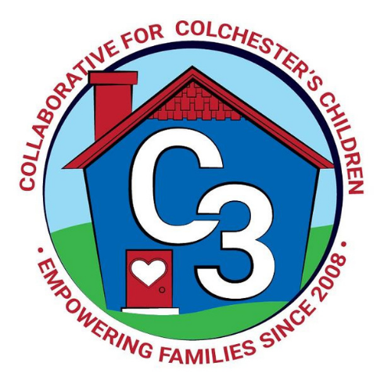
Colchester School Readiness Council
December 7, 2023
CES Conference Room/Google Meet
Time: 5:30 – 7:00 p.m.
Meeting Minutes

Attendance: Cindy Praisner, Kristina Swain, Jennifer Lombardo, Meghan Amado, Jennifer Rummel, Lindsay Therian

McKinney-Vento Homeless Update: No update.

OEC/SR Updates: There continues to be a lot of conversation in the early childhood circles about the K start date change. There is a push to get legislation changed as well as additional funding for subsidized preschool spaces by an action group. Unlikely to bring about change in time for the process that is already in motion. The OEC/CSDE is supposed to release family guidance soon. Additionally, the Blue Ribbon Panel released its final plan which has strategies to support workforce capacity development and increased access to Care 4 Kids.

SR Budget Update: C. Praisner explained that the Coordinator salary still needs to be corrected in the budget due to an error in where the funds are being drawn from. A request has been made to the Finance department and First Selectman’s office to correct this.
Discussions of possible revisions to the QE budget for the $1258 originally allocated for Town and Country included paying for CES staff for K screenings on Saturdays, sub payments for teachers taking COS classroom series at CES, facilitator payment for COS at CES, outdoor play equipment for Castle. M. Amado to get some estimates on cost for screenings and substitutes C.Praisner did investigate and it appears that we can use QE to pay staff for a Saturday screening date.

Current SR Classroom Status: C. Praisner reported that there is full enrollment.

SR Program Monitoring: C. Praisner reported that program monitoring for the Fall is complete.

Sparkler: Kaitlin Cassidy continues to attend a lot of events and is hosting two this month to promote the Sparkler app. We’ve been doing drawings to encourage parents to download the app but our data hasn’t really improved much as far as getting individuals to use the app.

Suggestions to improve use were to have Social Media posts created of playcards, Screen shots of how to get your results now and what a report looks like. Include this tips on our website as well. Sparkler should have its own dedicated page on our website. Timing with dual administration has been tricky at Castle as parents and teachers aren’t always completing the ASQ in the same time frame.

M. Amado will bring back the suggestion of including completion of the ASQ as parent input in the K waiver process.

SR Council Membership:
C. Praisner reviewed gaps in our SR Council membership. She hasn’t heard back from all prior members about continued participation. She is trying to finalize those members including the First Selectman (or a designee), a Health Professional, and a parent or business member.

Language Equity:
C3 is creating an ad-hoc team to work on developing a few strategies for supporting families that do not speak English. If anyone is interested in helping with the work, please reach out to C.Praisner.

Preschool Applications:
The School Readiness application will be released the first week of January this year to coincide with the lottery application process. People are already asking and completing last year’s application so it makes sense to move our process up to occur simultaneously with the lottery process. “Ber Babies” will get additional points on the Selection Rubric to help ensure that they are given priority placement.

K Waiver Process:
SRC will host a conversation about the waiver process with early childhood programs in town to help communicate the change with families. C.Praisner will also reach out to Early Care and Education providers in town to see how many “ber babies” they have in their programs and if they know the intentions of families to send or hold those children for planning purposes.
C3 will create Social media posts and they will include links to the district K website page.

2023-2024 Meeting Dates

January 25
March 14
April 18

Submitted by:

Cindy Praisner, Coordinator

