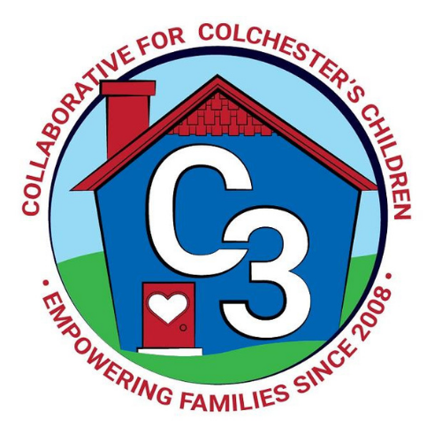
Colchester School Readiness Council
November 3, 2022
CES Conference Room
Time: 5:30 – 7:00 p.m.
Meeting Minutes

Attendance: Cindy Praisner, Laurie Buyniski, Judy O’Meara, Kaitlin Cassidy, Grace Landers, Jennifer Rummel, Maria McNichols, Lisette Stone

McKinney-Vento Homeless Update: J. O’Meara provided the council with an overview of the McKinney Vento Homeless Assistance Act so that members can gain an understanding of the background and purpose.

SR Budget Update & Current SR Classroom Status: C. Praisner updated the council on the budget as funds were lost due to open spaces.
CASTLE- All School Day- 9 am to 3 pm
- September- 6/9 loss of $1800
- October- 7/9 loss of $1200
- November 9/9 with 2 Not Yet 3s (Jan and March 2023 Birthday)
- Did not cap Family Fees this year
  - Range is $88 to $760 per month
CECP- 7 School Day 8:35 to 3:10 and 12 Part-day
- September- 7/7 SD; 9/12 PD loss of $1350
- October- 7/7 SD; 10/12 PD loss of $900
- November- 7/7 SD; 10/12 PD loss of $900
- Family fees are capped at CPS tuition rates (11 out of 17 families)
  - Range is $0 to $150 per month
SR Program Monitoring: J. Lenares scheduling Fall monitoring visits with programs.
Sparkler Program Use Data Review: C. Praisner reviewed the community Sparkler report, total of 99 children are logged into the app. Council members discussed that Parents need to sign up in order for teachers to see the child on the provider side of the app. Parents offered feedback on the app; activities to do with your child are helpful and a positive selling point for engaging families.

Overview of School Readiness Grant and Council Roles: C. Praisner reviewed a presentation from the state which provided an overview of SR Council roles and responsibilities. Colchester is one of 67 towns in the state to receive School Readiness funding. It is the responsibility of the council to serve all 3 & 4 years olds and improve the quality of all programs across Colchester. Council members agreed that all parent representatives (added as of July) should get a vote to help offer diversity. Recent updates include adjustment to the sliding scale, and review of council membership.

Self-Assessment Results: C. Praisner distributed and reviewed the results of the self-assessment. Council members discussed a variety of feedback topics including creating a guidance document for new members, changes to the decision making policy, how to better offer information to families, issues around wrap-around care for part-day preschool as well as before & aftercare.

2022-2023 Meeting Dates
Dec 8, 2022- canceled
January 26, 2023
March 2, 2023
April 27, 2023

Submitted by:

Laurie Buyniski, Assistant to the Coordinator

