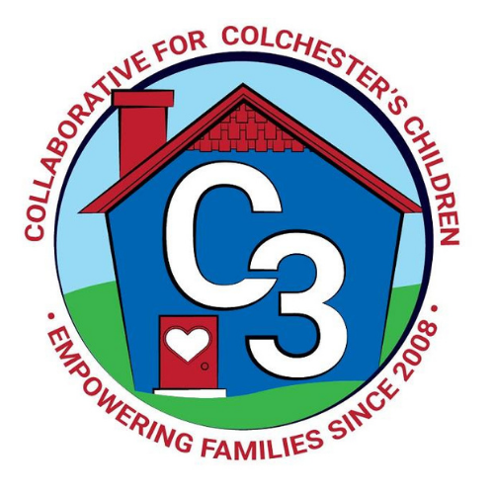
Colchester School Readiness Council
March 2, 2023
CES Conference Room
Time: 5:30 – 7:00 p.m.
Meeting Minutes

Attendance: Cindy Praisner, Laurie Buyniski, Judy O’Meara, Jennifer Rummel, Kristina Swain, Jennifer Lombardo, Lindsey Therian, Emily Feldhouse, Danelle Mauro, Meghan Amado

Welcome and introductions of new members: E. Feldhouse and D. Mauro are joining the council as Parent Representatives. L. Carli has decided to step down and we thank her for her contributions.

McKinney-Vento Homeless Update: None

Current SR Classroom Status: C. Praisner reported that Castle is currently full, CECP has one PD spot remaining.

SR Program Monitoring: C. Praisner reported that monitoring at Castle has been completed. Program continues to make progress toward meeting Professional Development requirements. There are two remaining classes at CECP to be completed.
SR Budget Update: C. Praisner reviewed the budget and noted that there are additional funds for programs through the enrollment grant and shared how to determine the amount for each program as shown on the attached spreadsheet (divide by 12 then multiply by 10 (months)).
Council members discussed the use of the CLASS Assessment tool and decided not to continue with it. Funds for certification ($250) will be reallocated in this year's budget. Professional development workshop on Phonemic Awareness will be offered by Erin Herman for local providers at a cost of approximately $150, to be paid out of CECP PD Paraprofessional funds as they aren’t being used. Council members discussed the use of the Heggerty tool for CASTLE, which includes online options, and was recently updated. (Digital kit $89/year, $179 bundle https://heggerty.org/ )
Discussed other uses for the Professional Development budget, such as staff retention, pre-literacy development, parent involvement, curriculum content and lesson plans.
Sparkler Update: Council members reviewed what the app entails for new members. Summary report is difficult to read. Programs provided updates:
Castle SR Classroom - 12 screened, 2 remaining (late starters), FD 14, FD Preschool 11= Total 37
CECP 65 screened, does not include birth to three or SPED, as those students are screened with another tool. 11 outside students screened, 23 scheduled for upcoming screening dates.

SRC Orientation Document: C. Praisner asked members to review documents and offer feedback.

Council members discussed the Transition to Kindergarten and plan to survey families in the Fall. Will update the survey that was used in previous years and reformat for next year. Council discussed a PreK/K Collaboration Meeting so that providers and representatives from the Kindergarten team can share information to help providers prepare students for the expectations of Kindergarten (What teachers are looking for, What we are seeing now, Struggles, What skills are most valued) C. Praisner will follow up to schedule a meeting in the spring

Application has been released for the 23-24 school year. C. Praisner will begin placing students in mid-May when the grant is approved.

Nutrition Quality Component: Council members discussed what is currently being done to meet the nutrition quality component requirement. Castle is reaching out to contact at St Joseph in order to schedule a mini-class or table set up; there may be options of different formats. CECP will find out what they are currently doing for nutrition and will report back.
J. Rummel offered the healthy eating box/book-it kit as a resource, and can potentially schedule a Saturday program.

RFP Update: C. Praisner reported the status of the RFP. The State is taking spaces from programs that have not been used. By March 9th, programs will report back the need for additional spaces. Determining factors include community need (income). Colchester is classified as a moderate childcare desert. Town & Country Early Learning Center has an existing site in Middletown, and so it may be possible to request Full Day spaces for the new building currently under construction in Colchester. Council discussed potentially requesting 8-10 FD spaces for this site which would keep current spaces at CECP and Castle. Funding for the Part Day slot is $4500, Full Day $8950. Need for School Readiness Full Day spaces may be increased with recent changes in the care4kids program.

Council members reviewed the schedule of meetings for BOS and BOE in order to move the grant process forward. Plan to add a meeting on April 6th and cancel April 27th, must submit signatures by June 1st but would prefer to have the complete application submitted on the May 4th. Local program application pieces are minimal this year. Programs are only required to add information to tables, no narrative section! C. Praisner will send out what programs need to complete.

Council members reviewed the plan for the Quality Enhancement budget. Currently have $3881 designated for ESGI subscription for CECP, J. O’Meara will ask the team if they want to continue using the tool. Funds for CECP Paras are not needed as PD is completed during school hours. COS Classroom - currently being offered by J. Lenares for providers, could offer this workshop for staff at Castle. C. Praisner asked the programs what their preference is for PD; plan and offer collectively OR staff selects virtual programs individually. At least 1 session of PD will be offered to community providers as a group, in order to maintain connection. C. Praisner will survey all providers to ask about preferences for PD.

The new OEC sliding family fee schedule is now percentage per week instead of $ amount; therefore, calculations are a little bit different, and new fees were released in October. Forms for determining family fees will be adjusted for FY24.

Council discussed the timing of promoting the SR application given the local school budget process. Budget meetings are scheduled for March 7th/14th, which may determine when CECP can pull the preschool lottery spaces.

J. O’Meara has a Pre K attendance survey which tracks the percentage of students entering K and will share data with the council.

2022-2023 Meeting Dates
April 20, 2023 (updated as of 3/31)
May 18, 2023

Submitted by:

Laurie Buyniski, Assistant to the Coordinator

