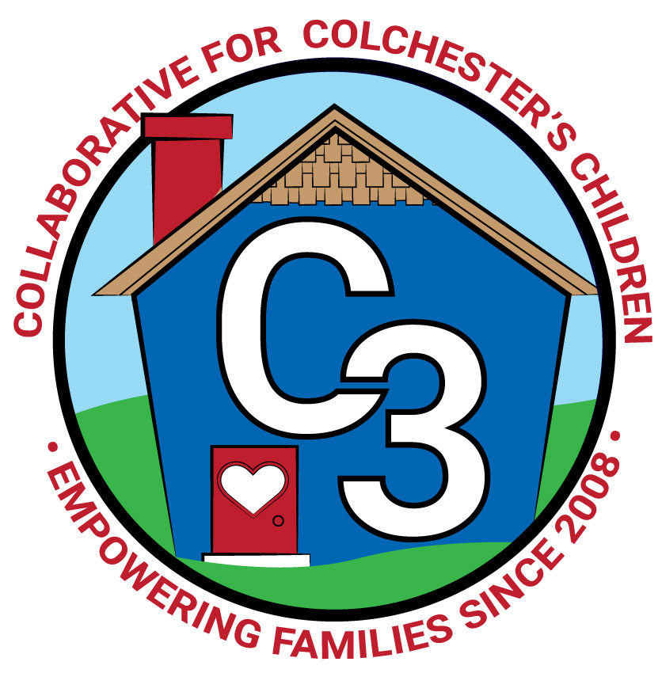
COLLABORATIVE FOR COLCHESTER’S CHILDREN
October 18, 2022
Leadership Work Group Meeting
Cragin/Google Meet Hybrid
9:00-10:30 am

Attendance: Abigail Dunbar-Willbanks, Nina Bryant, Teresa Messervy, Kerry Zrenda, Ashley Starrett, Cindy Praisner, Laurie Buyniski, Julia Lash, Beth Tiezzi, Brittany Hebert, Kate Byroade

Partner Updates
Cragin - Indoor & in-person storytimes will begin this Fall for the first time since Covid. Kindergarten classes will be coming for field trips, including puppet show and library card registration. Completed Family Place program with 15 families enrolled for Thursday morning series. Materials from CT State grant for summer enrichment program, which is the 2nd Step SEL Curriculum to be used for out of school time, has arrived.

TVCCA/WIC - Both Head Start and Early Head Start classrooms moved, Early Head Start now located at Bacon, sharing space with C3 Play & Learn Groups. Head Start moved to a different classroom, still in CES. Early Head Start enrolled 9/10, Head Start enrolled 8/15. Full enrollment is expected by the federal government. SNAP is automatic eligibility. Nation-wide workforce crisis impacting programs, will take a hard look at those operating under 50%. Programs will undergo evaluations, including class observations, focus areas for improvement, and non-compliance. WIC and EHS working on M-CHAT screening for autism in birth to three populations.

School Readiness - Preschool Spaces still available (2 PD at CECP, 2 SD at Castle). It has been challenging to fill spaces due to the district opening more spaces and offering longer day program as well as many families are looking for before & after care/full day programs. New facility to open in the previous bank building in front of Town Hall (Town & Country Early Learning Center). C. Praisner has been in contact with the director, operate another facility in Middletown which has a School Readiness Program in place. It was suggested to reach back out to Curley’s to see if they may have interest in providing full-day SR spaces.

JJIS - No COVID protocols, no reported cases. Free breakfast and lunch continue. Two new teachers in 4th and 5th grade. Planning a Family Learning Night (4/19) using funds from the School Store proceeds.

BOE - No Update. Rosemary Gignac will be C3 liaison.

C3 General Updates
- Annual Meeting held on 9/20 at Town Hall, Barbara Vita from Children’s Collective was guest speaker. Parent Council members organized a post-meeting outing at Fornarellis.
-Fall programming is running well. Joyful Noises (6 classes), Baby and Me (2 classes), Village virtual (1 group), Conscious Discipline Monthly - October, Circle of Security- Starts 10/18. Stroller Walks continue.
-SR Budget- Underspent for tuition due to unfilled spaces. New Circle of Security for the Classroom program is being offered for Providers in a monthly format. First workshop meets on 10/19.
-LECC Grant-Revisions in the works- Ends 12/31, working on supporting Parent Council Activities. Also completed the following:
Published flyer/insert in the RiverEast in September, included Calendar of Programs, Family Survey and Sparkler Information. Hosted Community Baby Shower on Oct 12th, seven families attended and three additional families will connect at a later date to receive gift baskets and information/resources. Event included activities, food and local resources for new parents.
Library Registration for two staff members to take part in Family Place training.

Parent Council Updates
-Parent Ambassadors attended the last Quarterly OEC meeting on 9/14. Learned what other collaboratives are doing. CT has become a model for other states considering how to implement similar work. C3 has been asked to host an in person meeting for Regional Parent Ambassadors, which would require a space that can accommodate a meeting for 30 people, as well as food and childcare. Will check dates to decide if Cragin is a possible option.
-Planning to host a pop-up event for families on an upcoming day off from school, possible dates include 11/8 and 11/11, with the theme of gratitude.
-Outdoor Yoga Night at Priam Vineyards with Twisted Dog yoga was a success. Co-leaders would like to schedule another depending on indoor space availability.
-Parents volunteered for three Farmers Markets (7/31, 8/21, 10/16) plus had a table set up on 9/17 during the Choose Love event. Most success when piggybacking on another event, such as Kid’s Day and Trick or Treat Day. Plan next year to attend only the markets with those themes, to maximize effort and not exhaust volunteers. Also, discussed having a table at additional town events such as Concerts on the Green and Holiday Homecoming.

Elect Co-Chair - Beth Teizzi has completed a three year term as Co-Chair, members thanked her for her service. Britt Hebert volunteered to fill the vacancy, members approved.

Budget Update - C. Praisner reviewed the 21-22 budget. Town funding of $25k has not been received due to an unapproved budget. There will likely be a referendum on November 15th or early December. On track for spending. Funding for the Family Empowerment Facilitator position, held by J. Lenares, depends on the upcoming ARPA meeting. PEP group raised enough funds to cover the cost of the Choose Love event, plus additional $170, Y&SS contributed to the event by purchasing some materials as well.

Strengthening LECC Grant - Funding ends 12/31; therefore, budget revisions will be made in order to be sure all project work can be completed.

Choose Love- Members discussed ways to incorporate the activities and themes of Choose Love into classrooms at CES, JJIS and possibly Joyful Noises classes. JJIS used the program last year, all teachers have a log in to access curriculum on the website; however, there has not been any direction from Administration as to how it should be implemented this year. K. Zrenda will look into this. Some production companies have a Kindness theme, as well as new Kindness Slips have been implemented at JJIS.
Choose Love Formula signs (purchased for the Choose Love event) have been placed at CES and JJIS. Choose Love commitment banner displayed on the Town Green. Members discussed using themes for pop-up family events.

Sparkler App Promotion- Winners of the September and October drawing have been chosen for a $25 gift card to Stop & Shop. J. Lash offered to share Sparkler info with CCNS families.

Meeting Dates for 2022-2023
Nov 29, 2022
Jan 17, 2022
Mar 7, 2022
May 2, 2022

Submitted by:
Laurie Buyniski, Assistant to the Coordinator

