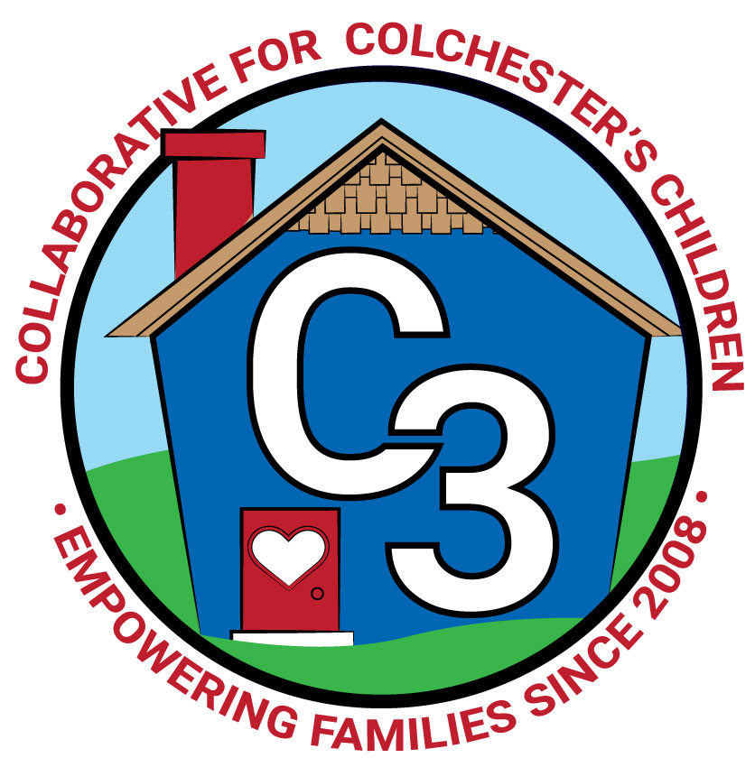
COLLABORATIVE FOR COLCHESTER’S CHILDREN
November 28, 2023
Leadership Work Group Meeting
Cragin/Google Meet Hybrid
9:00-10:30 am

Attendance: Cindy Praisner, Laurie Buyniski, Nicole Beauchamp, Brittany Hebert, Kerry Zrenda, Nina Bryant, Julia Lash, Kate Byroade, Meghan Amado, Kendra Dickinson, Dan Sullivan

Partner Updates
Cragin - Updating baby play area with Lakeshore toys and equipment purchased from LECC grant funds. New sensory panels received in memory of Kathy Nolan, can be changed out. K. Byroade developing a strategic planning process for the library, assembling a team of stakeholders, based on the hopes and dreams of the community.

TVCCA/WIC - No update.

JJIS - 2nd Step has begun in classrooms daily. Conversations about after-school clubs have stalled due to low staff availability. E. Buston and J. O’Meara may be exploring other options for a possible Spring session.

Youth & Social Services - No update.

CASTLE - Winter Wonderland fundraiser will take place on December 14th, Santa, raffle baskets, open to the public.

CPS - Budget season will begin after the holiday break. Upcoming events include:
-State of the Schools and Community Expo on November 29th at 6PM, open to the public, to share strengths and areas of focus at each school, performances from students across the district.
-Building the BOE budget on Dec 11th at 5-6PM at Bacon Academy media center

CES - Accepting waivers for K eligibility from families. Administrators will make contact to arrange assessment, observation in PreK, evaluation from PreK teacher, testing session to take place in Feb/March/April. Kindergarten section of the district website has been updated, including resources, what to expect in K, how to reach out with questions. Ten members of CES staff will participate in the Circle of Security classroom version to build foundational skills in the model.

Parent Council Updates
Parent Council Co-Leaders:
Colchester Co-Op Nursery School will be holding a raffle basket fundraiser during Holiday Homecoming to raise money for the 65th anniversary celebration.
A new parent has joined the Parent Council and will be taking on the role of Events coordinator, Rosemary Kelley. Next PC meeting will be on Thursday, December 14th to wrap up the year with a celebration. Food Drive taking place at CES and Bacon Joyful Noises classroom to be donated to Colchester Food Bank. Spring fundraisers have been scheduled with Inishmor and Mel’s. Looking for more volunteers to help with the Holiday Homecoming event. N. Bryant will be helping with the K transition survey.

Parent Ambassadors:
OEC December meeting was canceled.

C3 General Updates & Events
Fall sessions of Workshops and Play & Learn groups will end the first week of December. Winter session registration will begin mid-December. Spending LECC funds by the end of year, no longer able to purchase gift cards to pay for childcare so funds will be used to pre plan for future programs. Considering Peace at Home Parenting contract to offer virtual parenting courses on a variety of topics that serve a wide age range for families, relationship based. Currently waiting to hear back on the cost, would cover the entire town, possible partnership with Lebanon/Salem and may have funds from YSS to contribute. Program offers access to Spanish speaking courses as well. Creating a postcard mailer 6x9 to be sent to all households mid-December which will include QR code to be direct to C3 website, information about relationship-based programs, K Start date, Sparkler, drawing for entering email address. 75 seats have been purchased in Conscious Discipline online course, which will open to parents after schools, providers and Prek programs have reserved spots.

Event Schedule
Dec 9 - Sparkler Music & Signing event to be held at Jazzercise Studio, 10:30-11:30am
Dec 16 - Saturday Joyful Noises at Cragin, additional dates scheduled for the Spring

Budget Update
Fall programming will be paid out soon. SR budget is on track, some revisions were required due to the change in Town & Country Early Learning Center not participating in spaces this year.

Strengthening LECC Grant
LECC grant will likely offer C3 $15K for work January-June. Shifting Sparkler support funds due to receiving separate Sparkler grant and reallocating Parent Ambassador and Parent Ed funds because gift cards can no longer be purchased for childcare. Planning a new book review project, will purchase books for the parenting section at Cragin and hire social media writer to develop reviews for C3 website and create SM posts to promote the books. Possibly have additional funds for the Baby play area at Cragin. Marketing materials to be purchased include stickers, palm cards, tshirts, postcard mailer.

LWG Self-Assessment Results
Results of the self-assessment from earlier this year were reviewed by the council; good momentum, making progress, areas to work on include involvement of the First Selectman. C.Praisner will work to bring the new First Selectman on board. He is a member of the Executive Committee. The roles of the LWG needs some further explanation and understanding for members, Community awareness is a consistent goal (marketing materials, farmer’s markets, attending events where families are already attending).

Language Equity
K. Dickinson, District Coordinator of Multilingual Learners, shared an overview of her work with students across the district, how she serves families, obstacles/barriers they face with sometimes complex learning needs and how she works to set goals and help students reach them. C3 is creating an ad-hoc team to work on developing a few strategies for supporting families that do not speak English. If anyone is interested in helping with the work, please reach out to C.Praisner.

Upcoming Meeting Dates for 2023-2024
Tuesdays, 9:00 - 10:30 am
January 9
March 5
May 7

Submitted by:
Laurie Buyniski, Assistant to the Coordinator

