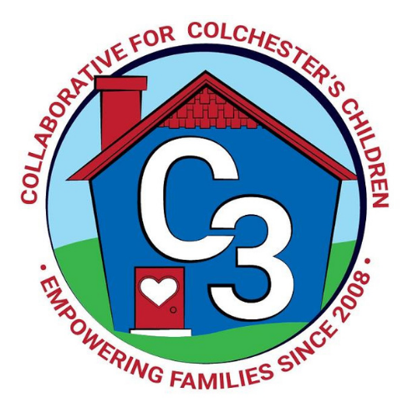
Colchester School Readiness Council
May 18, 2023
CES Conference Room/Google Meet
Time: 5:30 – 7:00 p.m.
Meeting Minutes

Attendance: Cindy Praisner, Judy O’Meara, Kristina Swain, Jennifer Lombardo, Meghan Amado, Kaitlin Cassidy, Grace Landers, Maria McNichols, and Danielle Mauro

McKinney-Vento Homeless Update: No update from A. Emory. The family discussed at the last meeting was provided a SR fee waiver for the remainder of the school year.

Current SR Classroom Status: C. Praisner reported that Castle and CECP are currently full.

SR Program Monitoring: Spring monitoring sessions are in progress. Programs were reminded to complete Professional Development plans before the end of the school year.

SR Budget Update: C. Praisner reported that spending is on track. Final tuition payments and payments to J. Lenares for monitoring and professional development still need to be made.

Spaces for 23-24: The following will be available for 23-24:
- Full-day spaces at Town and Country Early Learning Center
- School-day spaces at CASTLE
- Part-day spaces at CECP

Council Participation in 23-24: C. Praisner will reach out to each member to determine their availability to serve next year. A short discussion about meeting times concluded with keeping the time the same.

SR Application and Selection Process: C. Praisner reviewed the draft Selection Process document. The Council voted to approve the changes made. There haven’t been a lot of applications for SR yet. Please promote. Ideas to add to the First Selectman’s newsletter and Facebook posts, Cragin summer newsletter, and posting flyer at the new indoor play space were suggested. The goal is to begin selecting students for spaces by the beginning of June. C.Praisner will reach out to current part-day families that requested a longer day to re-complete a revised request for CASTLE or Town and Country spaces.

Self-Assessment: C. Praisner requested that each Council member complete the SR Council self-assessment Google document form to ensure that we are doing all that is required. It was emailed to everyone on the Council. Please complete by June 12.

Transition to K Survey: The group reviewed a prior transition to K parent survey and made changes. C.Praisner will create a draft Google form to circulate via email. A subset of current K parents and K teachers will also be asked to review for clarity and content. Goal will be to have the survey ready for incoming K families to complete by early October 2023.

2023-2024 Meeting Dates
TBD

Submitted by:

Cindy Praisner, School Readiness Liaison

