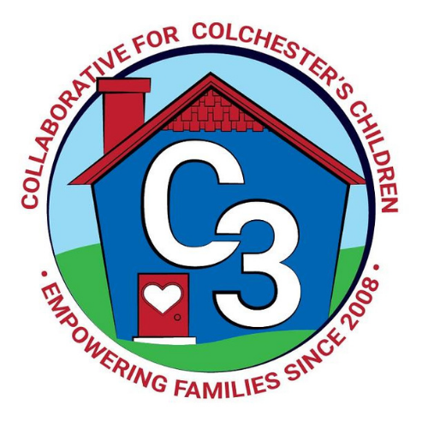
Colchester School Readiness Council
November 11, 2023
CES Conference Room/Google Meet
Time: 5:30 – 7:00 p.m.
Meeting Minutes

Attendance: Cindy Praisner, Judy O’Meara, Kristina Swain, Jennifer Lombardo, Meghan Amado, Kaitlin Cassidy, Jennifer Rummel, Laurie Buyniski, Teresa Messervy, Emily Feldhouse, Lindsay Therian

McKinney-Vento Homeless Update: No update from A. Emory. C. Praisner shared statistics of homelessness in CT. Efforts being made by Head Start with a voucher program to support families in New London county that are working and enrolled in HS, with section 8 housing for one year.

A hardship request was approved.

OEC/SR Updates: Beginning with the 2024-2025 school year, children need to turn 5 years old on or before September 1 in order to be automatically eligible for kindergarten. This is a change from the current kindergarten cutoff date of January 1. Families may appeal to have their child enter earlier and the district will conduct an assessment. According to Town Hall, there are currently 40 students in the window which would be impacted by the new law. 20 of those students attend preschool at CES. Screening dates for families that petition for the waiver will likely take place in March, April & May. There is a possibility of an additional tuition-based school day preschool classroom, and transportation via M&J is being discussed.

C. Praisner provided the following updates: this is the last year of enrollment funds, COLA is on-going, there is an OEC Scholarship Assistance program to support professionals in Early Childhood Education seeking a degree.

SR Budget Update: C. Praisner explained that the Coordinator salary needs to be corrected in the budget due to an error in where the funds are being drawn from. A request has been made to the Finance department to correct this.
Revisions to the QE budget are needed because funds were allocated to Town & Country; however, it is not currently a SR site and therefore the funds ($500 ECERS, $400 PD, $358 Heggerty) need to be reallocated. C. Praisner will find out if it can be used to pay staff for a Saturday screening date.

Current SR Classroom Status: C. Praisner reported that there is full enrollment.

SR Program Monitoring: C. Praisner reported that program monitoring for the Fall is complete.

Sparkler: C. Praisner introduced Kaitlin Cassidy who has taken on the role of Sparkler Coordinator for Colchester. K. Cassidy provided a report on community events and outreach efforts she has made to encourage families to download the app and complete the ASQ. Additional upcoming events include Sing & Sign music program on 12/9, Pop Up event at Storywalk 11/10, Joyful Noises at Cragin 12/16, Bobcat Preschool connection. Grant funds end Jan 31st.

SRC Self-Assessment:
C. Praisner reviewed notable areas of the SRC Self Assessment which was completed earlier this year. The council discussed the following areas:
-Work to improve awareness within the community
-Languages - reaching families that are non-English speaking and how the SR application may be offered in more languages
-Before/After Care - CES is discussing potential options with KinderCare
-How to Guide - referral process for providers is needed so that they know what to do when there is a concern about a student
-SRC orientation- discussed creating a new document to help new members clarify roles and understand the purpose of the council
-Confusion about the lottery vs. SR application process - The council discussed ways to help families understand the process and make it easier

Transition to K Survey: A collaborative effort among council members was made to revise a previous version of the Transition to K Survey, and sent out earlier this Fall. 55/151 families responded. Results include the following: most families attended the evening Orientation and Meet & Greet events, small attendance at daytime storytime sessions and therefore may consider hosting an evening session. CPS will make updates to the website and create a Kindergarten specific page with FAQs to help provide information to families that was difficult to find. 50% of respondents had not heard of Sparkler; the council discussed sending information through the Parent Square app to spread the word.

2023-2024 Meeting Dates
December 7
January 25
March 14
April 18

Submitted by:

Laurie Buyniski, Assistant to Coordinator

