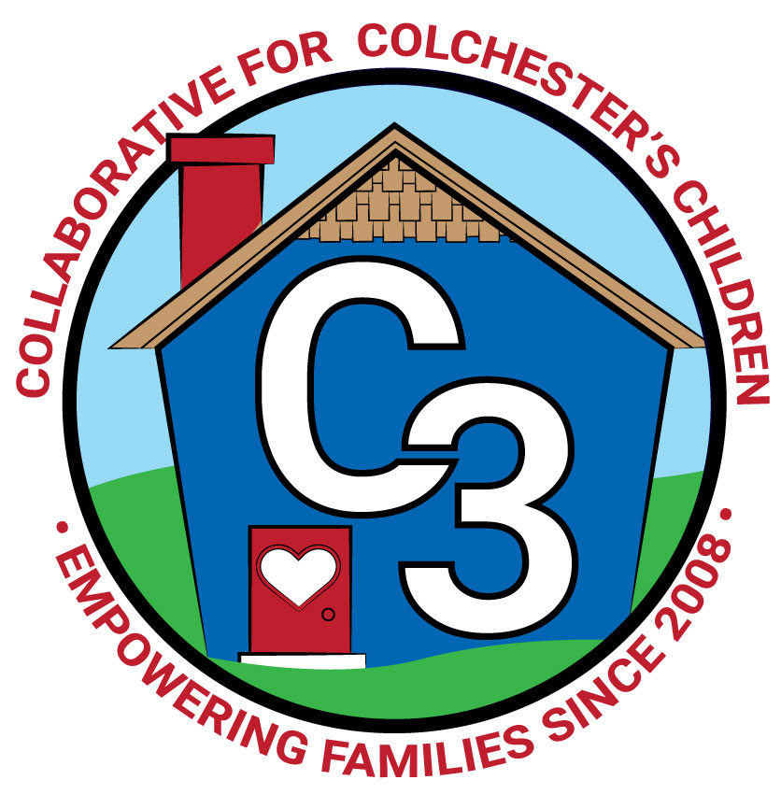
COLLABORATIVE FOR COLCHESTER’S CHILDREN
January 9, 2024
Leadership Work Group Meeting
Cragin/Google Meet Hybrid
9:00-10:30 am

Attendance: Cindy Praisner, Laurie Buyniski, Brittany Hebert, Kerry Zrenda, Nina Bryant, Julia Lash, Jennifer Rummel, Meghan Amado, Val Gaeto, Sharon Wilinski, Jamie Shannon, Teresa Messervy

Partner Updates
Cragin - Five week session of Storytime and Play with Me (12 months - 3 years) will begin at the end of January. Eight week session will run in the Spring. Starting to plan for the Summer reading program.

TVCCA/WIC -
TVCCA has had some leadership changes. Head Start and Early Head Start are on ‘under enrollment plans’, have 12 months to look at causes and potentially propose changes. Saturation of services, eligibility (housing) and need for infant/toddler care are contributing to the issue. EHS is currently full in Colchester.

WIC - Working to recruit new families through outreach efforts, will send flyer for C3 to distribute. There is some uncertainty nationwide about continued funding, cuts would impact the ability to provide services to families. Currently hiring for a part-time nutritionist in the Norwich/New London area.

JJIS - Beginning to plan the Learning night event, now called Family Fun Night, March 14th - theme will be Journey/Adventure. K. Zrenda shared that there has been discussion of opening PD time for teachers across the district for independent learning, allowing professional liberty in choosing topics that are of interest to them and therefore could potentially participate in C3 offerings such as COS and CD, etc.

Youth & Social Services - Through a partnership with C3, a new virtual portal of Parent Education is available to all Colchester families covering a variety of topics, spanning all age ranges, called Peace at Home Parenting. Will run a pilot program to try it out over the next 6 months, also in cooperation with the town of Lebanon. A Community Conversation is scheduled for Thursday, January 18th at JJIS, 6-7PM, called “Talk. They Hear You.” AnnMarie Maffuid, LMFT, of Colchester Counseling, will talk to parents about establishing themselves as the trustworthy source for information on alcohol and other substances. 5th & 6th grade students will attend a separate session at the same time. Planning a follow-up to ‘Supporting Your Anxious Child workshop.’

CES - PreK Lottery Applications are accepted through January 31st. Google form has been created for the K-waiver process to gather information and for families to select an assessment date. Deadline to apply for the waiver is March 1st. There will be an information night for families and providers on January 25th, to share details about the process. M. Amado will send the flyer to C. Praisner to distribute to providers through email and Facebook. Families will likely be notified by the end of April regarding whether or not the waiver has been approved so they have enough notice to plan. Families that move into town may be evaluated in April/May/June as needed. Anticipate that approximately 40 students are impacted by the new K start date. CES team will use a full holistic picture to determine if the child is ready for Kindergarten, including the Dial-4, which also requires parent input, as well as observations in the current Prek setting.

Parent Council Updates
Parent Council Co-Leaders:
The November Parent Council meeting was canceled; however, many events in December kept members busy. Santa Letter writing table at Holiday Homecoming was a success, distributed hot cocoa kits and SEL board books. Stress Relief Yoga Night and Year-end Celebration at Fornarelli’s were well attended. Changing Parent Council meetings to all evenings, instead of alternating day and evening due to member availability.

Parent Ambassadors:
OEC December meeting was canceled.

C3 General Updates & Events
Fall sessions of Workshops and Play & Learn groups ended. Winter session registration is open. Spent LECC funds by the end of year. Peace at Home Parenting contract was signed to offer virtual parenting courses on a variety of topics that serve a wide age range for families, relationship-based. Made possible through partnership with Lebanon/Salem and YSS. A postcard mailer (6”x9”) was sent to all households in Colchester in mid-December which included QR code direct to C3 website, information about relationship-based programs, K Start date, Sparkler, drawing for entering email address; however, due to a distribution issue it was not received on all mail routes. A few of the 75 seats still remain for the Conscious Discipline online course. Will begin PEP, FLIP IT (sessions for both providers and parents), COS with CES staff. Due to Bacon midterms, Joyful Noises classes may move to Ruby Cohen depending on weather. Discussed possibly moving Village (due to low enrollment) to in-person. Planning self-care programs for caregivers to offer connection, stress relief - topics include healthy eating (how to make a charcuterie board) and relaxation (how to make your own shower steamers).
Sparkler events on January 9th and 20th to help caregivers fill out ASQ, provide support and opportunity to complete the screening tool.

Budget Update
Coordinator salary needs to be adjusted because funds are not being taken out of the correct account, a request was made to the finance department to solve this issue.
Funds to purchase gift cards for childcare were reallocated to purchase Parent Education books (C3 Staff recommendations), with the help of a consultant, a book review project was completed and will be announced soon.
Professional development opportunities include CD Online sessions 70/75 seats taken, CD Anger & Rage, COS Facilitator Training.

Strengthening LECC Grant
Additional anticipated funding from LECC - $15k Jan-June, $15k July-Dec. Potentially cover the costs of Parent Council stipends, Freelance Social Media consultant, Sparkler Coordinator, will flip funding for childcare & playgroups as we are no longer allowed to purchase gift cards with the funds.

PreK to K Transition Survey
A survey was sent to all current Kindergarten families in October to understand how they felt about the Transition to Kindergarten process. Fifty-five responses were received. Areas that were evaluated include Storytime sessions, CPS website, having help to navigate the process, and information/orientation night. CES Administrators are making changes based on feedback.

Check-In
C. Praisner asked members to consider how meetings are working; what's going well, what could be changed or improved. Will plan to discuss it at the next meeting.

Upcoming Meeting Dates for 2023-2024
Tuesdays, 9:00 - 10:30 am
March 5
May 7

Submitted by:
Laurie Buyniski, Assistant to the Coordinator

